**ISTE240 – Web and Mobile II**

**Individual Project Part 1 - Midterm Assignment**

**This project is due Thursday, March 3, 2022 at 11:59pm.**

**Overview:** Create a web site about a place where you've lived or visited. You will be graded on your basic design, organization of information, content, navigation and use of HTML5 and CSS3 (both text and positioning). Include as a part of your project a separate linked page documenting what you have done in each grade category, and a separate page to cite any sources you used.

**Ten Total Pages for this Midterm Project.**

**6 Content pages about your home town or favorite place you have visited. These pages need slideshows and text.**

**1 Contact page or an about page (information about you when you went to your favorite place.**

**1 Newer version of your Exercise 3 – I expect to see checkboxes and radio buttons – New image in thankyou page. Exercise 3 now must work and send data to 2 email address yours and** [**RITISTprofessor@rit.edu**](mailto:RITISTprofessor@rit.edu)

**1 Page you create of how you completed the full rubric for this Midterm Project.**

**1 Reference page.**

**The Details:** Your website should include at least 10 pages of information about this place (that’s 10 separate .html files, including the homepage), with an index page located at people.rit.edu/~[abc1234]/ISTE240/project1/index.html.

You must write all materials for this individual site in your own words. You may not use anything from anywhere else at all. You may obtain images for the site, but you must create all graphics for this site. You may not use anything from anywhere else at all but the photographs. In other words, this is an original website that you make all by yourself (and be sure that the ‘obtained’ images are properly cited).

**Design:** Divide the content up into appropriate "chunks" of information, and design the site in a way that enhances the presentation of the content. This means you need to think about how to organize the site, how to label it, and how to navigate through it, keeping your audience in mind. Your work will be evaluated on the quality of your content, as well as your information organization and navigation.

Use CSS for text formatting and layout. Do not use inline or document-based styles unless appropriate (and I expect a comment in each case as to why).

**Browsers and Screens:** You can assume your users will be using a current generation browser(s) to view your pages, but don't assume that it will (or won’t) be IE, or that it will be a specific hardware platform or screen size. So use media queries to enhance the experience on small screens.

**JavaScript Slideshow:** Required screen layout. Please notice the margins. Only one is required

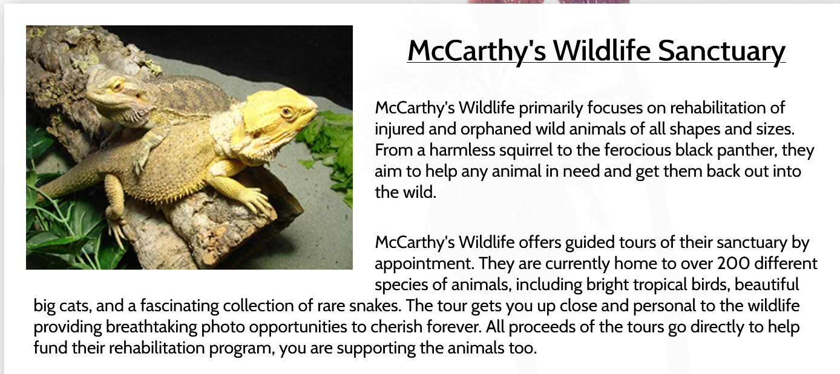

**Some graphical and interaction design notes:**

* It should be obvious to a site visitor that all pages are part of the same site. Use repetition. Include the same components on all pages: site title, site logo, formatting (page title, content, navigation).
* The global navigation should be accessible on all pages. In other words, a site visitor should be able to jump to any top-level page from any other page within the site.
* Prevent your site visitor from getting lost. At a minimum, there should be a page title on every page. Breadcrumbs can be very helpful, especially the page is more than two levels deep. Add clues as to what page I’m currently in! □ Make your site easy to navigate – both between pages and within pages. If you have pages with long content, consider a 'back to top' link at the bottom of them.

Consider a navigation system with fixed positioning.

* Page titles (title tags) should reflect the actual content of the page, not just be something generic, like "John's site about NYC".
* Your site must display well across all major, modern browsers. If you use a technique that is not supported by a particular browser, make sure it fails gracefully. DO NOT use WordArt (for anything, ever).

**Some content notes:**

* You should have a map. Your site is about a physical location, after all, and a picture is worth a thousand words. The map should relate to your content. If you find a map that mentions a bunch of tourist spots, but none of them are mentioned in your site, that's not the map for you. Don't be afraid to use more than one map,

e.g. one that shows places you mention within your site, another that shows where your location is within the surrounding area, etc.

* Unless you took the photos yourself, there must be an explicit citation for each photo that accompanies each photo.

* You are being graded on your content. Do not expect two sentences to sufficiently describe your location.

* Write the content as if you would actually want to read it yourself. Try to convince site visitors that this is a place they would really want to visit. Don’t be lazy on this!

**The Reference Page**

You must cite all of your references on your ‘references’ page. You must have HYPERLINKS that work to your sources and a description of what you took from that source and where that is inside this project. Be very clear for each source’s hyperlink and include the following:

|  |
| --- |
| The DATE that source was updated (I understand it is hard to find that date on some pages) |
| What you took from that source i.e. picture of what or logo |
| Where you inserted that information in this project, what page, location on page |

An example of what I am looking for on your reference page for each source is the following

|  |  |  |  |
| --- | --- | --- | --- |
| http://www.plymouthtwp.org/ | Source updated   January 8, 2022 | Copied town logo and used it in updated survey/form old exercise 4 page form.html in the header |  |

**The ‘grading’ page** You must include a page that documents all of the things you’ve done in this site that satisfies the grading criteria.

**There should be NO typos.**

Spelling should be perfect. Grammar should be excellent. If English spelling or grammar isn't your best subject, get someone to proofread your site.

**Some code design notes** Make sure your code is easy to read. Use plenty of whitespace, indentation, and comments. INDENT!

* Your code structure should make sense (one CSS file linked to all pages; similar CSS selectors grouped together; no HTML tables for non-tabular data).
* Your CSS file should be commented
* You must use HTML5 and all pages must validate – submit your URL for the validation.
* You must use HTML5 semantic/structural elements where appropriate (header, aside, article, nav, footer etc.)
* You may not use any code (including HTML and CSS) that you did not write yourself.
* Focus your screens to have EXCELLENT COLOR CONTRAST.

**Grading Criteria**

**You will be graded on your:**

□ Good Design Techniques – CRAP - Color Contrast is a MUST.

* Organization of information – text and graphics make sense

□ Content – interesting read, excellent grammar, perfect spelling

□ Navigation – easy to get around, intuitive, well labeled

□ Use of HTML5 and CSS3 (both text and positioning)

□ A separate linked "Reference" page

You will lose 10% for not having a "References" page.

* Document what you have done in each and every grading category above, which is linked from your homepage.
* That you **modified your exercise 3** and included it in this project and make the form submit button work to send the forms contents to multiple email addresses.
* **Many Media Queries** – I want this project to be very “Mobile Friendly”
* Must have your own coded JavaScript Slide shows. See sample lecture files.
* JavaScript mouse over pictures. Two identical size pictures in the same location

**To receive an A** your site must be well written, have excellent graphics that flow with the text, and be appropriately organized. It must be way above average. Just Beautiful!

We will discuss more on this project in class in the coming days.

**P.S. –** The final individual project will be a **modular site and will be re-visiting this topic**, adding in a bunch of technology. The more complete you make this version – the less you will have to correct on the final version! The final version will also be responsive for mobile, but you can do that now if you wish!

**To reiterate about the quantity of pages**

6 – Content pages about a place you have visited – they need slideshows and text.

1 – page you can call contact page or about page that is about you and your email address and your college major here at RIT and any other data you thing could be appropriate to you and this place you have visited such as when you went or how often you have been there.

1 – Working **UPDATED** version of your exercise 3 that you initially completed on Week 4, but now has changes that reflect this project and sends emails to multiple email addresses.

1 – Reference page – site all your sources, provide HYPERLINKS that work to your sources and a description of what you took from that source and where that is inside this project.

1 – Separate page that documents what you have done in each of the grade categories. Make sure you list (document) everything that you have done to fulfill the grading categories - Grading Rubric